Instruction Manual
CORNER MOVERS

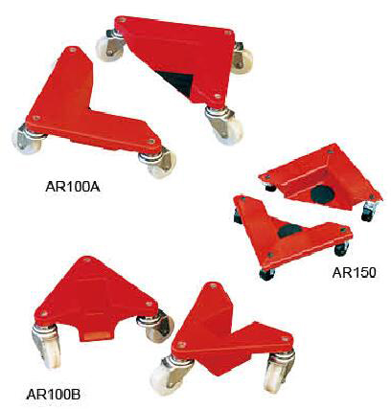

Note: Owner/Operator must read and understand this instruction manual before using the corner movers.

Thank you for choosing our corner mover. For your safety and correct operation, please carefully read the manual before use.

- GENERAL SPECIFICATIONS
Model |  | AR100A | AR100B | AR150
Max. Load Each | (kg) | 100 | 100 | 150
Castor Diameter | (mm) | Dia.50x20
Load Height | (mm) | 15
Overall Size | (mm) | 305x165x85 | 195x165x85 | 366x204x85
Frame Material |  | Aluminium | Aluminium | Steel
Net Weight per Set | (kg) | 5.6 | 4.8 | 8

- OPERATING INSTRUCTIONS
  - Corner mover has a certain loading capacity which is used as one of transporting tools to handle the office supplies and the furniture etc..

  - Features:
- Low height, safe transportation;
- Small force, easy transportation;
- Small equipment, convenient storage.

  - 1) Easy to position-lift one side of load by a transport jack and slide in corners, then repeat for other side.
2) Each four pieces of AR100A, AR100B and AR150 is one set to use.
3) AR100A, AR100B and AR150 respectively load 100kg, 100kg and 150kg, each has three steering wheels suitable to slide in every directions.(The load shall be placed securely to prevent loosing and failing.)
4) The texture of all the steering wheels of corner mover is nylon inside and polyurethane outside, especially suitable to the well decorative offices.

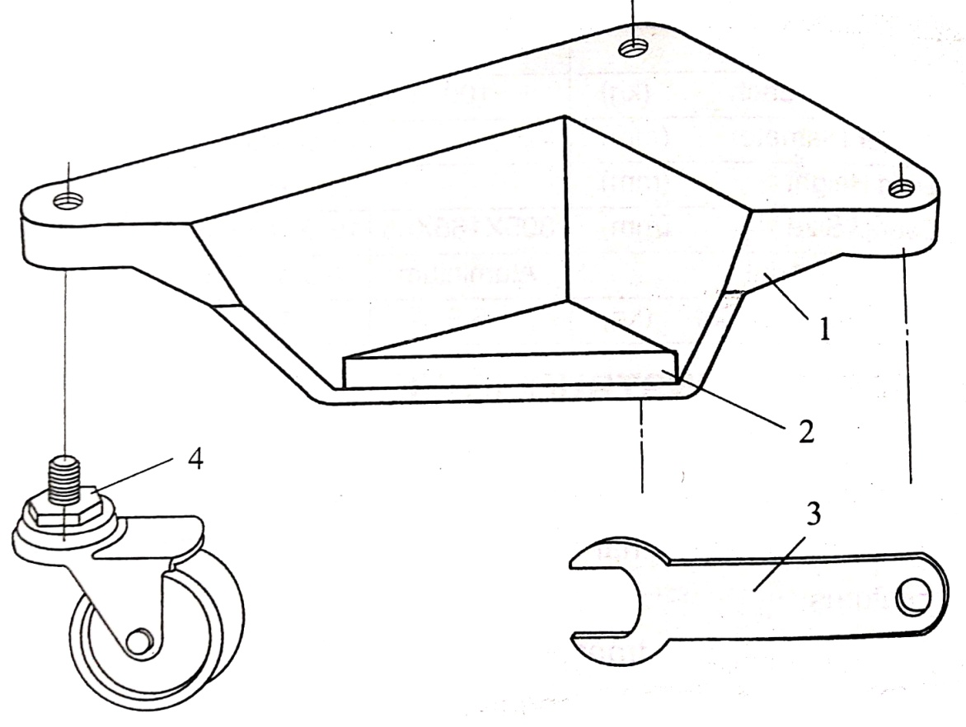

Fig. 1 AR100A

NO. | DESCRIPTION | QTY
1 | Base | 1
2 | Safety washer | 1
3 | Spanner | 1
4 | Steering wheel | 3

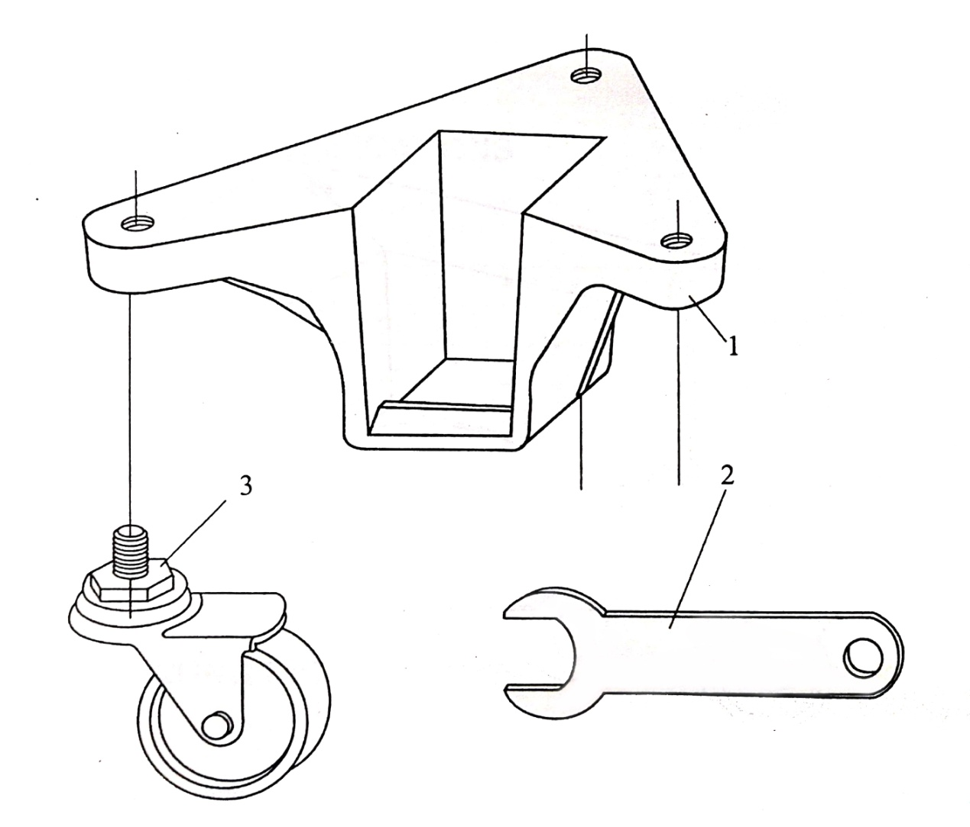

Fig. 2 AR100B

NO. | DESCRIPTION | QTY
1 | Base | 1
2 | Spanner | 1
3 | Steering wheel | 3

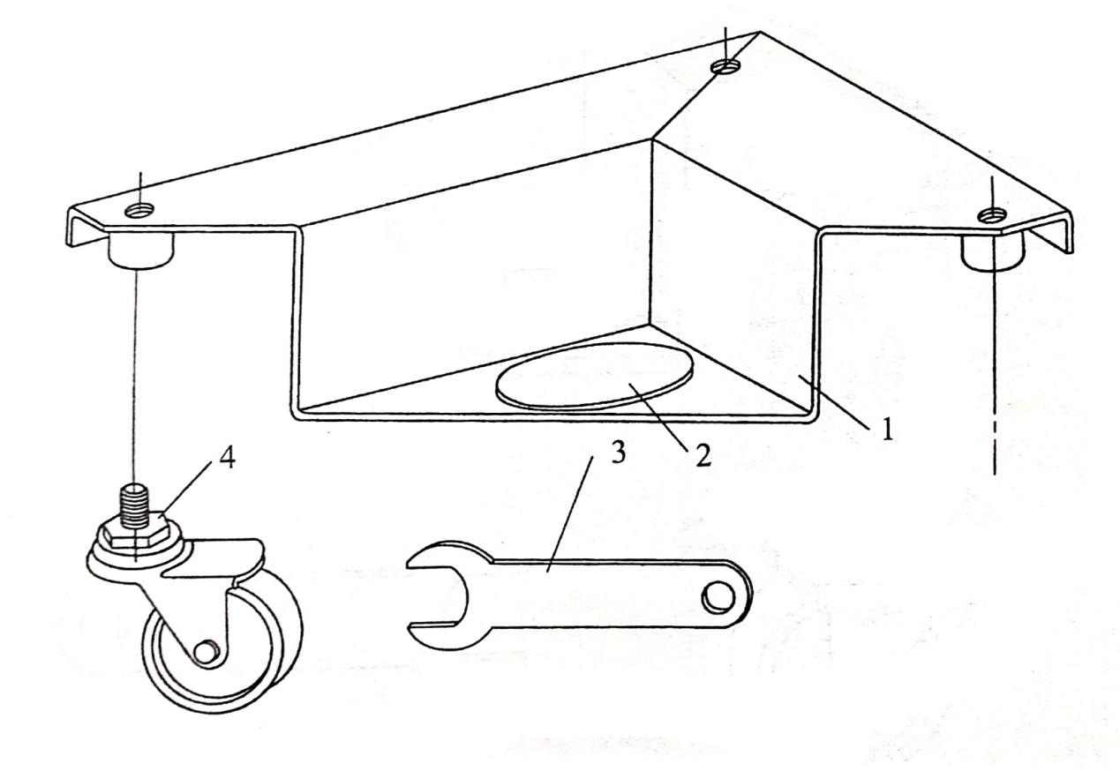

Fig. 3 AR150A

NO. | DESCRIPTION | QTY
1 | Base | 1
2 | Safety washer | 1
3 | Spanner | 1
4 | Steering wheel | 3

